Presentation and use of the new function “hvparameters”

Role of the new function “hvparameters”.

The new function ‘hvparameters’ will provide a simple user interface, in a pop-up window, for:

- Initialising the global parameter structure HV

- Editing parameter values

- Saving the current parameter set to a user-specified file with the extension .pas

- Restoring parameter sets from existing .pas files

It is required that the functionality of this pop-up window is similar to that provided by the PARAMETERS window in the DOS version of HVLab. First version of this pop-up window can be seen in figure 1:

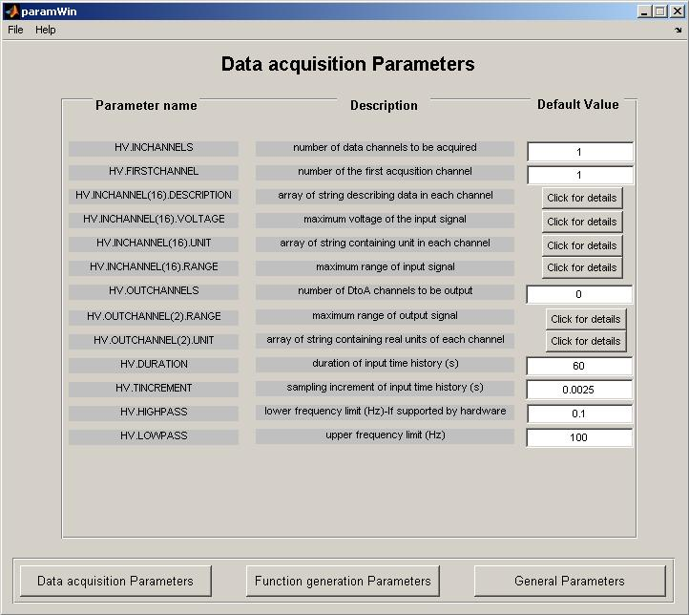
Figure 1: User interface for the function “hvparameters”.

Global parameter structure

Default parameters for many of the functions in the HVLab toolbox are defined by fields in a global structure named HV. This structure needs to be created and initialized at the beginning of every HVLab session. This was usually done using the function “hvinitialise.”
The parameters defined in Table 1 will be created and available when using the function “hvparameters”:

Table 1. Definition of variables in the global parameter structure
Parameter name | Description | Default value
Analogue data acquisition and output
HV.INCHANNELS | number of data channels to be acquired | 1
HV.FIRSTCHANNEL | number of the first acquisition channel | 1
HV.INCHANNEL(16).DESCRIPTION | array of strings describing data in each channel | ['channel 1' …'channel 16']
HV.INCHANNEL(16).VOLTAGE | maximum voltage of the input signal | [5…5]
HV.INCHANNEL(16).UNIT | array of strings containing units of each channel | ['m/s²' …'m/s²']
HV.INCHANNEL(16).RANGE | maximum range of input signal | [25 … 25]
HV.OUTCHANNELS | number of DtoA channels to be output | 0
HV.OUTCHANNEL(2).RANGE | maximum range of output signal | [10 10]
HV.OUTCHANNEL(2).UNIT | array of strings containing units of each channel | ['m/s²' …'m/s²']
HV.DURATION | duration of input time history (s) | 60
HV.TINCREMENT | sampling increment of input time history (s) | 0.0025
HV.HIGHPASS | lower frequency limit (Hz) - if supported by hardware | 0.1
HV.LOWPASS | upper frequency limit (Hz) | 100.0
Creation of data sets
HV.UNIT | data units as string variables | 'm/s²'
HV.DURATION | duration of created time history (s) | 60.0
HV.TINCREMENT | sampling increment of time history (s) | 0.0025
HV.FINCREMENT | frequency increment of spectrum (Hz) | 0.0
HV.AMPLITUDE | peak amplitude of function | 1.0
HV.OFFSET | offset applied to function | 0.0
HV.HIGHPASS | lower frequency limit (Hz) | 0.1
HV.LOWPASS | upper frequency limit (Hz) | 100.0
Spectral analysis
HV.FINCREMENT | target frequency increment (Hz) | 0.0
HV.WINDOW | spectral window | 'HAMMING'
Digital filters
HV.HIGHPASS | high-pass cut-off (Hz) | 0.1
HV.LOWPASS | low-pass cut-off (Hz) | 100.0
HV.FILTERPOLES | number of poles in filter | 4
Program control
HV.MESSAGES | Enables reporting of statistical information | 1 (TRUE)

Table 1: Definition of variables in the global parameter structure

Description of the user interface under “hvparameters”

General aspect of the parameters window

Parameters from table 1 are divided into 3 groups of parameters, called “Data Acquisition Parameters”, “Function Generation Parameters” and “General Parameters”. These 3 groups are directly accessible via 3 push buttons localized at the bottom of the user interface window, as shown in figure 2:

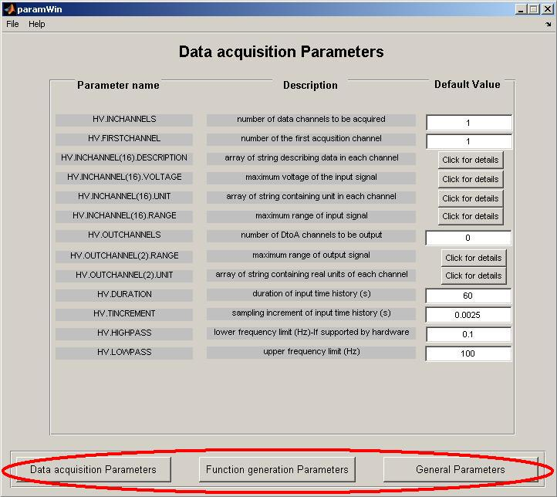
Figure 2: Parameter groups button in user interface for the function “hvparameters”.

By clicking on one of these pushbuttons, the corresponding parameters will be shown in the active window, and it will then be possible to edit them. Title of the table of parameters currently shown can be found at the top of the window (for figure 2: “Data acquisition Parameters”).

Specific types of edit boxes will appear according to the type of data required. Example: for HV.WINDOW (parameter containing information about the type of spectral window used), a small defined list of different window’s type will then be available to choose, as seen in picture 3:

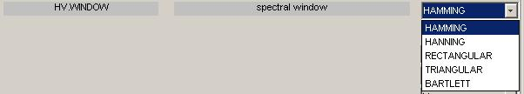
Figure 3: List for parameter with multiple choice

Parameters editing properties

Whenever a new value is entered into an edit box, this new value is automatically updated to the corresponding global variable. This allows the user to update parameters value and then use the corresponding global variable in other function, without having to close the parameters window or to save the parameters in a file.

For multi-channel data, a button “click for details” will show, in the parameters window, details of all channels for the corresponding type of parameters. The number of represented channels for each multi-channel parameter depends on the number of INPUTCHANNELS and OUTPUTCHANNELS.
When more than 2 channels are required, editing the parameter for the first channel will then let a box appear which allow the user to copy the data from channel 1 to all remaining channels. This will prevent the user to manually edit each box with the same type of data for all channels and may save some time. The question box is shown in figure 4:

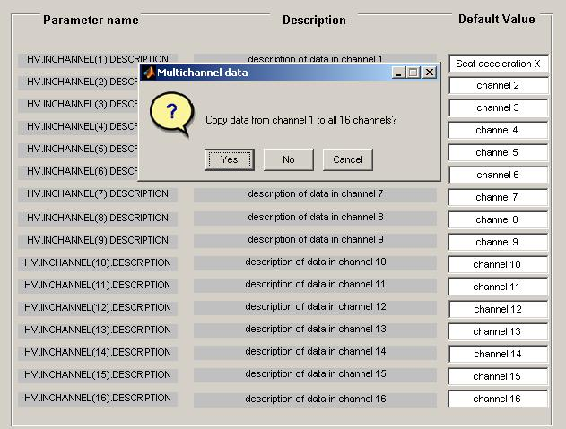
Figure 4: Multi-channel question box to copy data

Saving and loading parameters

“hvparameters” also allows the user to save or restore parameters sets. This is done by opening the menu “File”, situated at the top of the parameters window, and by choosing the appropriate action in the submenu: “save”, “open” or “load defaults data”. Details of this menu are given in figure 5:

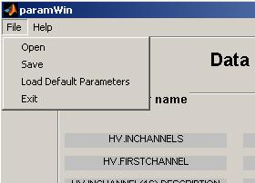
Figure 5: File submenu in the “hvparameters” user interface

Saved parameters files automatically have the extension “.pas”, and it is not possible to load files with any other type of extension. It is also important to save and load parameters files in the current work directory of Matlab, where the function “hvparameters” is situated. If the parameter file is situated in another directory, it is then necessary to copy this parameter file to the “hvparameters” directory.

Closing the “hvparameters” user interface

To exit the user interface, it is necessary to open the “File” submenu and then to click on “Exit”. Before closing the window, a message box will appear to ask if the actual parameters need to be saved in a parameter file, as shown if figure 6. Clicking “yes” will save the parameters in a file determined by the user, “no” will close the window without saving, while “cancel” will return to the parameters window, hence cancelling the closing process of the window.

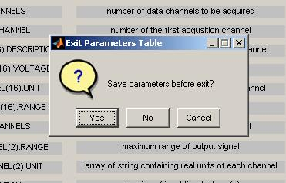
Figure 6: Message window before closing the user interface of “hvparameters”.

Development and limitations

This function “hvparameters” and the associated parameters window represent a first approach for a user friendly interface to edit parameters used in HVLab. According to the test results and the feedbacks from the users, the aspect of this window might change in order to facilitate its access and to fit with new requirements.

This version of the “hvparameters” function does not constrain parameters to appropriate data types and ranges: it is possible, for example, to enter a number of channels which is 2.3, or to have a voltage of 50000V. This type of user constraint will be developed later, after discussing and choosing an interface type for “hvparameters” which satisfies the needs of the users.

